Beach

Ocean Guardians Beach Cleanup: Santa Monica Edition  
  
Date: April 20, 2024.   
Time: 9:00 AM to 12:00 PM.   
Location: Santa Monica Beach, California

Organiser: Ocean Guardians Foundation.  
About the Organiser: The Ocean Guardians Foundation works to preserve marine ecosystems and promote ocean conservation. Our objective is to raise awareness about the importance of clean seas and inspire communities to act through beach cleanups, educational programmes, and advocacy campaigns.

Contact Information:

Email: OGFco@gmail.com

Phone: +1-555-123-4567

Description: Join us for a community-led beach cleanup to help protect our coastal ecosystem. To protect marine life and ecosystems, we will remove waste and debris from the shoreline with the help of local volunteers and environmentalists. We will offer gloves and trash bags. Let us work together to have a positive influence!

Categories: Environmental Cleanup, Community Service

Pic goes to the top of the article:

Workshop

Sustainable Energy Expo: Harnessing Solar Power  
  
Date: May 5, 2024.  
Time: 2:00 PM to 4:00 PM.  
Location: GreenTech Hub in New York City.

Organiser: Sustainable Energy Alliance.  
About the Organiser: The Sustainable Energy Alliance is dedicated to promoting renewable energy solutions and encouraging sustainable habits in communities globally. Our mission is to expedite the transition to sustainable energy by educating, resourcing, and assisting individuals, businesses, and politicians.

Contact Information:

Email: SUSEAco@gmail.com

Phone: +1-555-987-6543

Description: Learn about the benefits of solar energy and how to harness the sun's power for a more sustainable future. In this enlightening event, Sustainable Energy Alliance specialists will explore the most recent advances in solar technology, incentives for solar adoption, and best practices for solar system installation and maintenance.

Categories: Renewable Energy, Seminar

Location: GreenTech Hub, New York City

Pic that goes to the top of the article:

Files (pics) that upload in this category:

workshop

Green Thumb Society's Urban Gardening Workshop  
  
Date: June 15th, 2024

Time: 10:00 AM - 1:00 PM

Location: City Community Center, Chicago

Organiser: Green Thumb Society.  
About the Organiser: The Green Thumb Society aims to promote urban agriculture, food sovereignty, and community resilience through gardening instruction and advocacy. Our objective is to empower individuals and communities to grow their own food, create green spaces, and reconnect with nature in urban settings.

Contact Information:

Email: contact@greenthumbsociety.org

Phone: +1-555-789-0123

Description:

Dive into the world of urban gardening and learn how to transform abandoned lots, roofs, and balconies into vibrant green spaces. This session, led by professional gardeners from the Green Thumb Society, will cover a variety of subjects such as soil health, plant selection, water saving, and organic pest management. Whether you're a first-time gardener or an experienced green thumb, join us as we explore the joys and advantages of growing edible and beautiful plants in the city.

Categories: Gardening, Sustainability, Community Service

Location: City Community Center, Chicago

Pic goes to the top of the article:

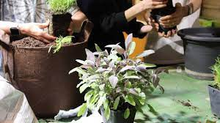

Additional image/files:

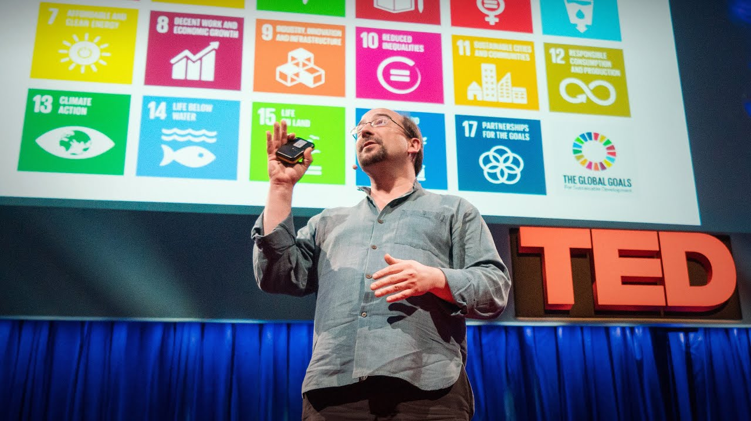

Hiking

Redwood Wilderness Trek: A Journey into Nature  
  
Date: July 10th, 2024

Time: 8:00 AM - 3:00 PM

Location: Redwood National Park, California

Organiser: Wilderness Preservation Society.   
About the Organiser: The Wilderness Preservation Society works to safeguard and preserve wilderness regions for future generations. Our organisation works relentlessly to promote the conservation of pristine natural landscapes, biodiversity, and ecological integrity through public outreach, environmental education, and stewardship programmes.

Contact Information:

Email: info@wildernesspreservation.org

Phone: +1-555-456-7890

Description: Travel through the ancient redwood woods of Northern California to explore the beauty and wildlife of one of the world's most iconic wilderness locations. This guided walk, conducted by professional Wilderness Preservation Society guides, will take you off the beaten route and deep into nature, where you'll learn about the importance of wilderness protection and the threats to these gorgeous forests. With magnificent landscapes and wildlife sightings along the route, this immersive outdoor experience is sure to inspire amazement and admiration for nature's treasures.

Categories: Outdoor Recreation, Nature Exploration, Conservation

Location: Redwood National Park, California

Pic goes to the top of the article:

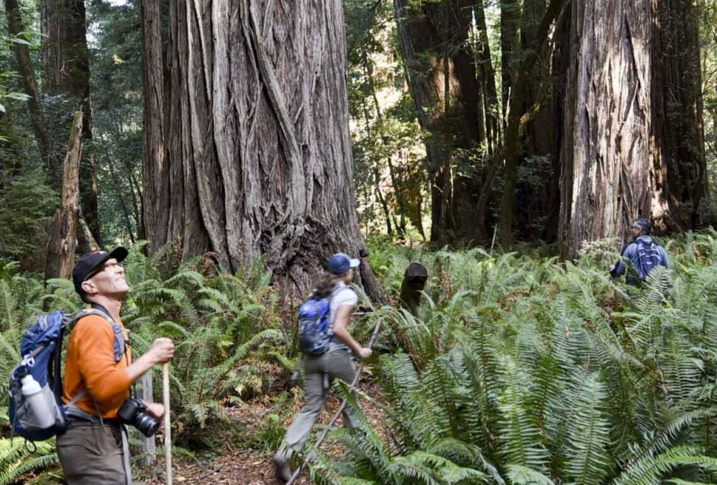

Additional files:



Seminar

Zero-Waste Living: Practical Strategies for Sustainability Seminar  
  
Date: August 20th, 2024

Time: 6:00 PM - 8:00 PM

Location: EcoLiving Co-op, Portland

Organiser: Sustainable Living Collective.   
About the Organiser: The Sustainable Living Collective is a grassroots organisation that promotes environmentally friendly lifestyles, reduces waste, and fosters resilient, sustainable communities. We aim to inspire people to live in peace with the environment and with one another through workshops, skill-sharing events, and community activities.

Contact Information:

Email: info@sustainablelivingcollective.org

Phone: +1-555-321-0987

Description:

In this entertaining class sponsored by the Sustainable Living Collective, you will embrace the zero-waste lifestyle and discover practical tips and methods for decreasing your environmental footprint. Our professional facilitators will provide useful insights and tangible techniques for living more sustainably, including mindful consumption and waste reduction, as well as DIY alternatives and sustainable buying practices. Join us as we look at how little adjustments can help create a greener, more sustainable future for everyone.

Categories: Sustainability, Waste Reduction, Seminar

Location: EcoLiving Co-op, Portland

Pic goes to the top of the article:

